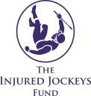
Campbell Gillies Memorial Ball

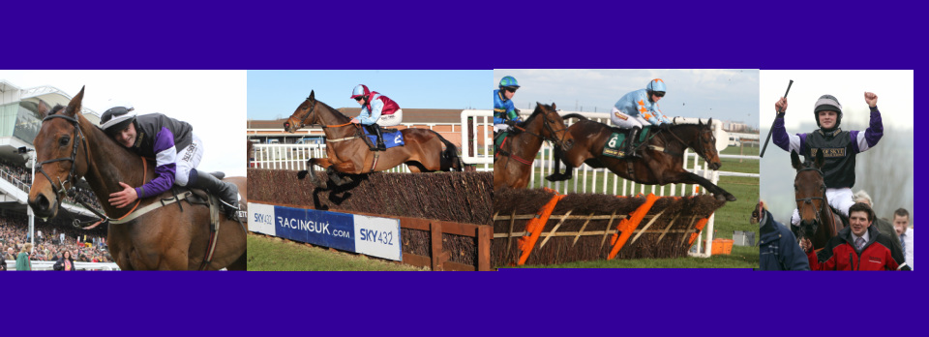
28th June 2014, Aintree Racecourse
BOOKING FORM
Number of tickets at £60 each (tables of 10) No.
Mr/Mrs/Miss/Ms Name _____________________________________________________________
Address ___________________________________________________________________________
______________________________________Postcode____________________________________
Tel. No________________________________ Email _______________________________________
Names of Guests (Please supply names and titles)
(If you require a bigger table please contact Jaimie on details below)
1 |  | 2
3 |  | 4
5 |  | 6
7 |  | 8
9 |  | 10

Are any vegetarian meals required? Yes/No Please state how many
PAYMENT (Booking will not be accepted until payment is received in full)

Amount Due: £___________________ payable to Campbell Gillies Memorial Ball
Please return form to Miss Jaimie Duff, The Barn, Middleton of Aldie, Fossoway, Kinross, KY13 0QJ

